The Library

APC-2016-part1.txt has 8 chapters.

APC-2016-part2.txt has 10 chapters.

CPP-2016-part1.txt has 26 chapters.

CPP-2016-part2.txt has 25 chapters.

NDC-2016-part1.txt has 17 chapters.

NDC-2016-part2.txt has 21 chapters.

NPP-2016-part1.txt has 9 chapters.

NPP-2016-part2.txt has 9 chapters.

PPP-2016-part1.txt has 3 chapters.

PPP-2016-part2.txt has 2 chapters.

**Confusion Matrix**

|  |  |  |  |  |  |  |
| --- | --- | --- | --- | --- | --- | --- |
| Confusion Matrx  Actual/Predicted | APC | CPP | NDC | NPP | PPP | Error Rate |
| APC | 0 | 5 | 2 | 1 | 0 | 1.00 |
| CPP | 1 | 23 | 2 | 0 | 0 | 0.12 |
| NDC | 0 | 6 | 11 | 0 | 0 | 0.35 |
| NPP | 0 | 0 | 2 | 7 | 0 | 0.22 |
| PPP | 0 | 2 | 1 | 0 | 0 | 1.00 |

After training and testing our random forest, it was unable to clearly distinguish each party’s manifesto. The random forest could not identify the first section (actual chapters) of the APC Manifesto against its second section (predicted chapters). The PPP Manifesto also suffers the same fate. No section of all the Parties’ Manifestos matches that of the CPP Manifesto.

**The OOB Error Rate**

OOB estimate of error rate: 34.92%. This is quite high because it is near an average point.

The graph on the below shows those stop words which are most useful in distinguishing manifestos from each other. We see that the NDC Manifesto uses the words “over”, “at” and “under” more frequently than any other party. The words “not” and “I” are most frequently used by the PPP. Finally, the words “our” and “is” are most frequently used by the PPP.

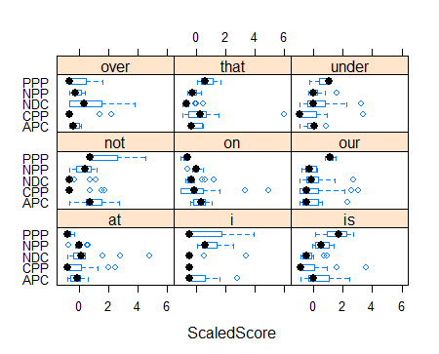

To test the model, we pulled one other manifesto by these five manifestos and got the following confusion matrix:

**Guess**

|  |  |  |  |  |  |
| --- | --- | --- | --- | --- | --- |
|  | APC | CPP | NDC | NPP | PPP |
| APC | 0 | 7 | 0 | 3 | 0 |
| CPP | 0 | 25 | 0 | 0 | 0 |
| NDC | 0 | 15 | 6 | 0 | 0 |
| NPP | 1 | 2 | 1 | 5 | 0 |
| PPP | 0 | 1 | 0 | 1 | 0 |

